Dr. Cheryl L Brown, Director  Jacksonville City Council  904.630.1452  CLBrown@coj.net | 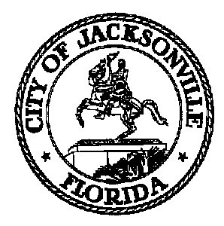 | 117 West Duval Street, Suite 425  Jacksonville, Florida 32202
TASK FORCE ON SAFETY AND CRIME REDUCTION

Meeting Notice

June 5, 2019
5:00 p.m.

TO: Task Force Members and Subject Matter Experts

Sam Newby, Vice Chair | Francois Brown | William (W.C.) Gentry | Sean Mulholland
Lori Boyer | Ricky Brown | Ellen Glasser | Michael Munz
Charles Moreland | Camille Burban | Shelley Grant | Ceil Pillsbury-Schellenberg
Lakesha Burton | Betty Burney | Constance Hall | Alicia Sitren
Stephen Siegel | Josh Cockrell | Phyllis Hall | Timothy Sloan
Rob Mason | Larry Cook | Marian Hannah | Vicki Waytowich
Joe Peppers | Richard Danford | Darcel Harris | Donna Webb
Jennifer Blalock | Frank Denton | Preston Harris | Shamika Baker Wright
Warren Jones | Amy Donofrio | Sam Harrison
Mia Allen | Sabrina Edwards | Carolyn Herman
Brandon Griggs | Ben Frazier | Linda Joseph
Clifton Anderson | Tom Geismar | Ronnie King

FROM: Mark Griffin, Chair

SUBJECT: 20190614 Meeting Notice Task Force on Safety and Crime Reduction

Notice is hereby given that the Task Force on Safety and Crime Reduction will meet Friday, June 14, 2019 at 9:00 A.M. The meeting will held in the Council Chambers located at 117 W. Duval St., 1st Floor, City Hall - St. James Building. For additional questions, please contact Crystal Shemwell at 904-630-1404 or via email cshemwell@coj.net.

When attending Task Force meetings, members are to park in the parking garage located on the corner of Main and Duval Street (Library Garage) to receive free parking. Please see the Legislative Assistant for parking validation.

CLB/cs
cc: Cheryl Brown, Council Director
Carol Owens, Chief of Legislative Services
Jeff Clements, Chief of Research
File
cityc@coj.net

Pursuant to the American with Disabilities Act, accommodations for persons with disabilities are available upon request. Please allow 1-2 business days notification to process; last minute requests will be accepted, but may not be possible to fulfill. Please contact Disabled Services Division at: V(904) 630-4940, TTY-(904) 630-4933, or email your request to KLMcDan@coj.net.

